* Download and install poll mailbox trigger plugin
* Then we can see the option under build triggers

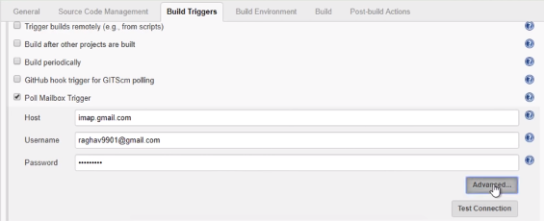

* We can test the connection
* We can go to advanced settings and use the below options to setup the advanced email properties

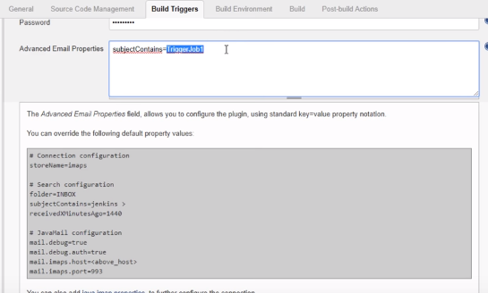

* Also, we can schedule the interval to check the email regularly

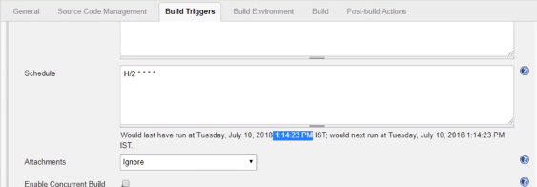

* So, as per advanced email properties above, if we send any email which contains subject as triggerJob1. Jenkins will build the job automatically
* Now if we test the connection, we can see the matching email count as below

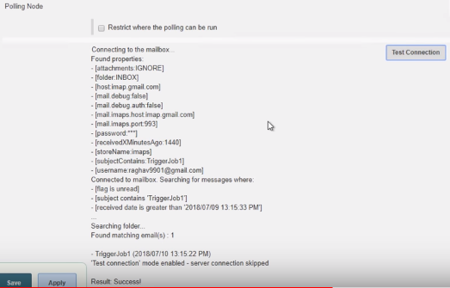

* Console output as below

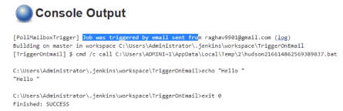

**Trigger builds remotely:**

* **Trigger builds remotely** work with some scripts

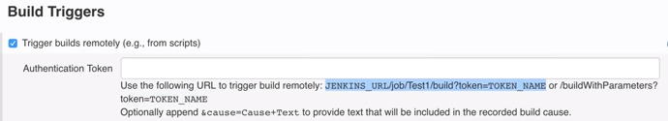

* Add token there like 1234. This is just like a password
* Copy that url and paste in another tab of browser
* Change the JENKINS_URL to our server url and TOKEN_NAME should match what we have given for authentication token as below
* http://54.175.210.75:8080/job/job1/build?token=akhil
* If we run the url, the job will get triggers. This is how we trigger job remotely